Activity 1:

Assignment: Modify the main method to create your own comic panel with a speech balloon. (ComicPanel.java)

Changing Panel Picture to favorite super hero (Obama)
Step 1: Locate a picture of your favorite super hero. Save image as JPEG file.
Step 2: Change “MattJennyCorn.jpg” to “obamasuper.jpg”
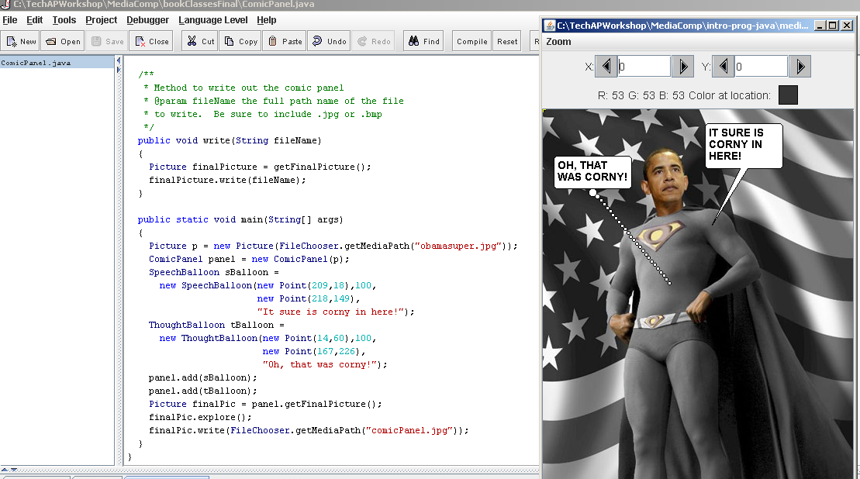

Step 3: Deleted the java code for the thought balloon.
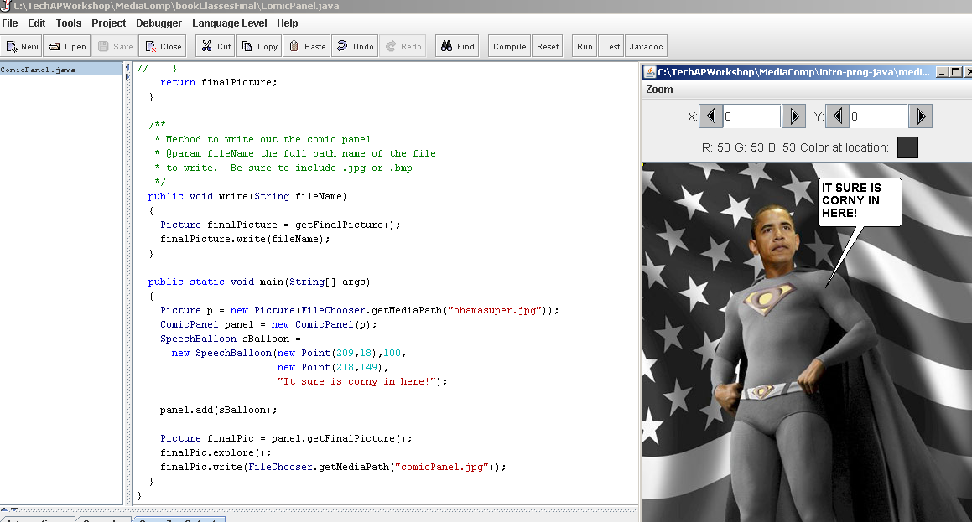

Step 4: Change the words in the SpeechBalloon:
“Kids ROCK for BARACK!”

Step 5: Position your speech ballon
New Point (209,18),100,new Point(198,97)

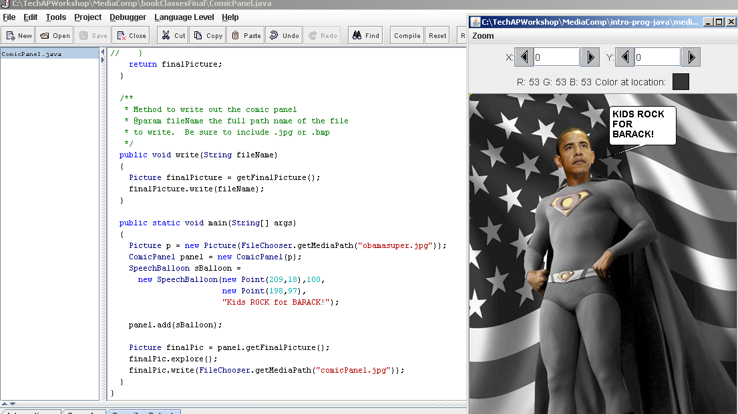

Answer

/**
* Method to write out the comic panel
* @param fileName the full path name of the file
* to write. Be sure to include .jpg or .bmp
*/
public void write(String fileName)
{
Picture finalPicture = getFinalPicture();
finalPicture.write(fileName);
}

public static void main(String[] args)
{
Picture p = new Picture(FileChooser.getMediaPath("obamasuper.jpg"));
ComicPanel panel = new ComicPanel(p);
SpeechBalloon sBalloon =
new SpeechBalloon(new Point(209,18),100,
new Point(198,97),
"Kids ROCK for BARACK!");

panel.add(sBalloon);

Picture finalPic = panel.getFinalPicture();
finalPic.explore();
finalPic.write(FileChooser.getMediaPath("comicPanel.jpg"));
}

