ACTIVITIES / ANSWER KEYS
Donna Marsh
Donna.Marsh@cobbk12.org

Four activities with answer keys highlighted in yellow.

Activity 1:

Assignment: Modify the main method to create your own comic panel with a speech balloon. (ComicPanel.java)

Changing Panel Picture to favorite super hero (Obama)
Step 1: Locate a picture of your favorite super hero. Save image as JPEG file.
Step 2: Change “MattJennyCorn.jpg” to “obamasuper.jpg”
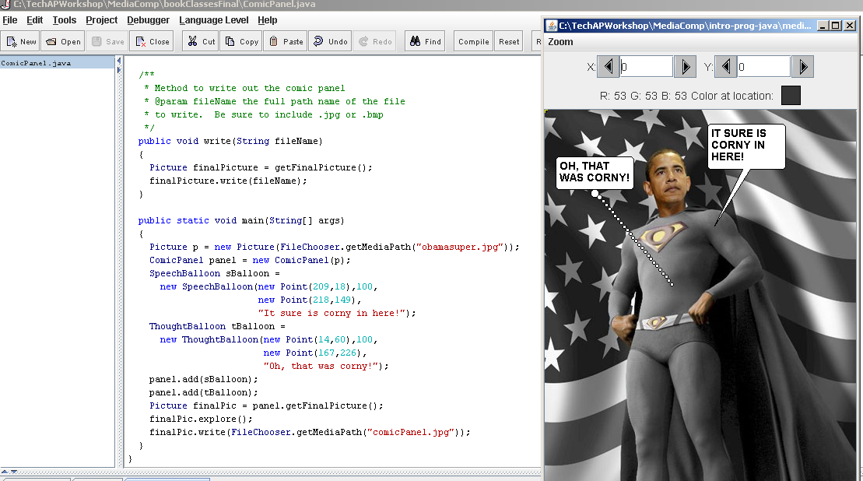

Step 3: Deleted the java code for the thought balloon.
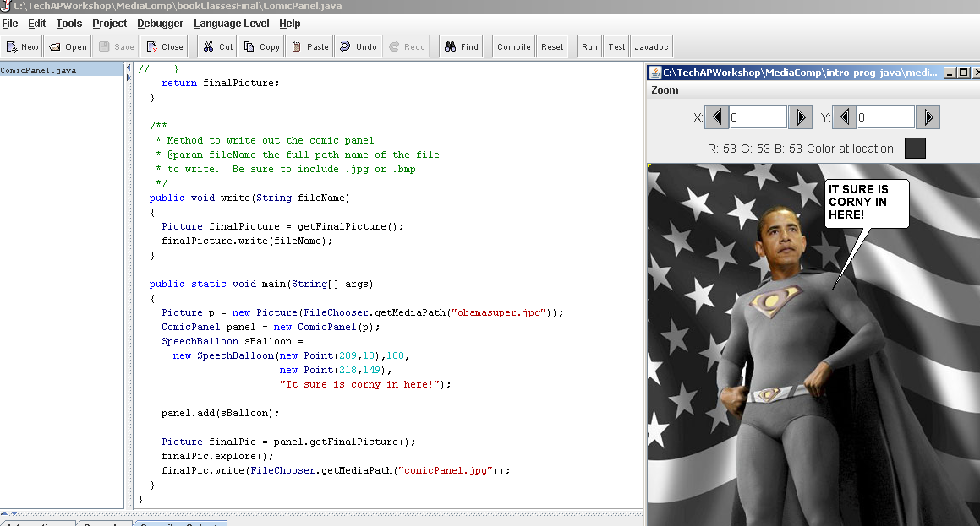

Step 4: Change the words in the SpeechBalloon:
“Kids ROCK for BARACK!”

Step 5: Position your speech ballon
New Point (209,18),100,new Point(198,97)

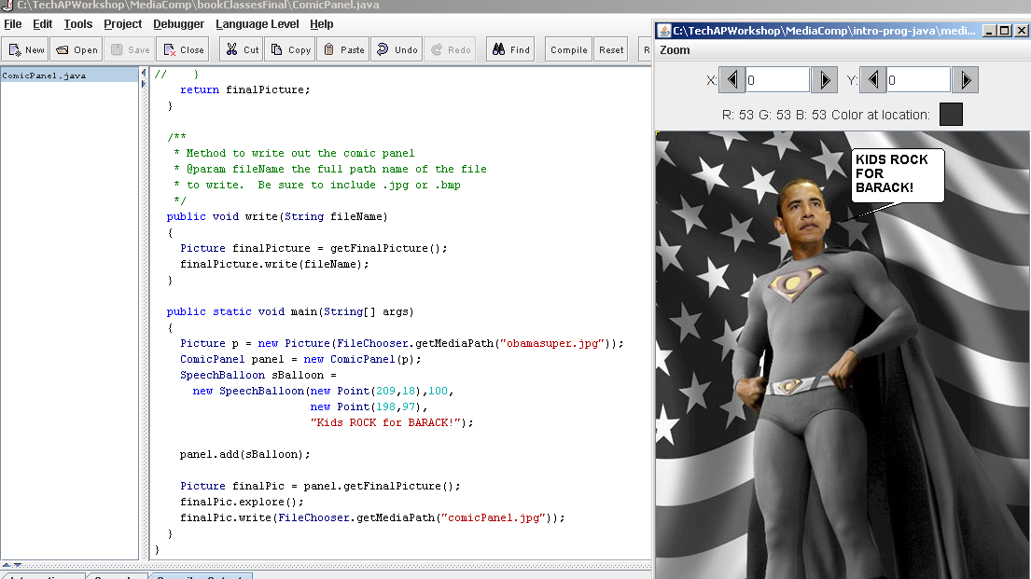

Answer

/**
* Method to write out the comic panel
* @param fileName the full path name of the file
* to write. Be sure to include .jpg or .bmp
*/
public void write(String fileName)
{
Picture finalPicture = getFinalPicture();
finalPicture.write(fileName);
}

public static void main(String[] args)
{
Picture p = new Picture(FileChooser.getMediaPath("obamasuper.jpg"));
ComicPanel panel = new ComicPanel(p);
SpeechBalloon sBalloon =
new SpeechBalloon(new Point(209,18),100,
new Point(198,97),
"Kids ROCK for BARACK!");

panel.add(sBalloon);

Picture finalPic = panel.getFinalPicture();
finalPic.explore();
finalPic.write(FileChooser.getMediaPath("comicPanel.jpg"));
}

Activity 2:

Modify Bug.java to put a rock into the location it previously occupies. Run BugRunner to see the Bug leave rocks.

Answers

/**
* Moves the bug forward, putting a rock into the location it previously
* occupied.
*/
public void move()
{
Grid<Actor> gr = getGrid();
if (gr == null)
return;
Location loc = getLocation();
Location next = loc.getAdjacentLocation(getDirection());
if (gr.isValid(next))
moveTo(next);
else
removeSelfFromGrid();
Rock rock = new Rock(getColor());
rock.putSelfInGrid(gr, loc);
}

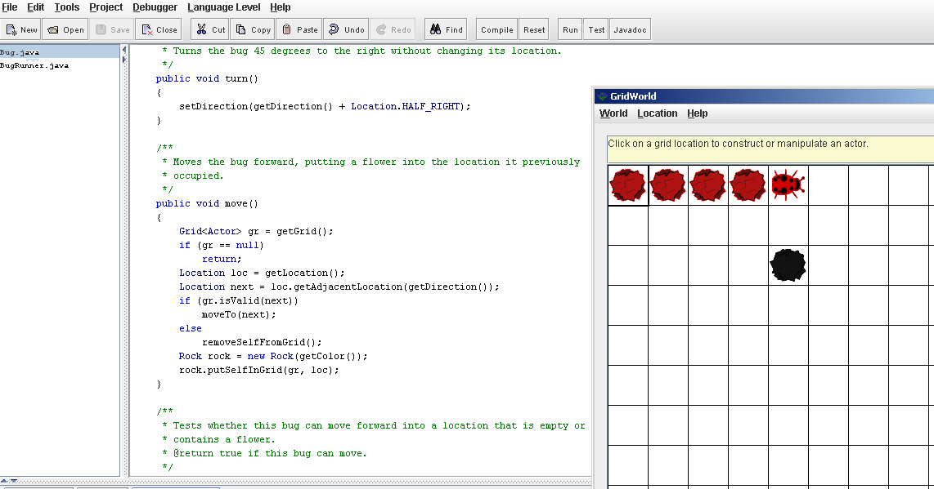

Activity 3:
Playing Amazing Grace Song

Step 1: JVM
Edit
Preferences
Add the following jmusic.jar and java-source
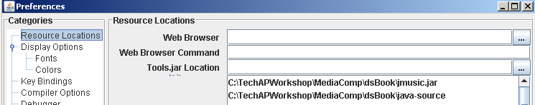

Step 2: Open (AmazingGraceSong.java)
This file is located : MediaComp/dsbook/java-source/AmazingGraceSong.java

Step 3: Add the following code (main) at the very end before the last bracket. (This assist with locating the main program.)

public static void main(String[]args)
{
AmazingGraceSong song = new AmazingGraceSong();
song.showMe();
}

Step 4: Compile
Step 5: Run (The following window will pop up)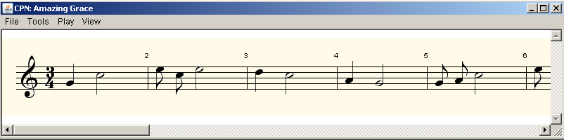

Step 6. Click Play, Then Play ALL. (The song Amazing Grace is Playing)

ANSWER: Listening to The Song Amazing Grace

Other Explorations:
Students can change the instruments to play the son by:
Tool
Set parametes
Change Instrument (click Apply) 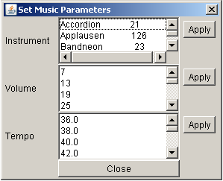

Students can also change the Temp and Volume.

Activity 4
Intro Activity to Teaching Objects and Classes

Objective:
The student will be able to understand what an object is and the difference between an object and a class.

Materials:

- Clay-Dough different colors
- Different sizes of cookie cutter (small, medium and large)
- Suggested types of cookie cutters (Classes)
Circle (Class) Square ( Class) Flower (Class)

Procedure for Day1 :

Each group is given a set of cookies cutters (i.e. circles, squares).
Roll out clay dough. Use cookie cutter to cut out your shapes. Each group has a different shape and size cookie cutters. Students will group cut out shapes.

Note: You can adjust the questions to fit your cookie cutter shape. These questions are design using the circle shape clay dough cut out.

Questions:

1. How would you classify your cut out shapes (objects)?
Students will group cut out base upon shapes. Circles, squares, flowers etc.
2. How are they the same?
Circular , PI, all have a radii, and circumference

3. How are they different?
Color, size , different areas, different radii and different circumference.

4. What is an Object?
A person, place, or thing (noun).
An object has data (attributes, fields).
An object can do (verb) something. An object has operations (methods)

5. What are your Objects? The different size circles.

6. What is your class? Hint: The shape of your cookie cutter..
Circle

7. What is a class?
Grouping of objects with the same data and operations; the way we classify an object.
Circle (i.e. square, flower, rabbit)

For example: The red clay dough shape is a circle.
The blue clay dough shape is a circle.
The pink clay dough shape is a circle.

8. What do all circles have (Each object has it own data)? Note: You can
have the student to measure to obtain the data.

Radius
Diameter
PI

9. What can a circle do (Verb, action)? Hint: Calculations. Note: You can have
the students calculate the area and circumference.

Calculate area,
Calculate circumference

Procedure for Day 2
Objective: The students will be able to write a class and main program (application) to calculate the area of a circle.

Note: A circle shape doesn’t do much in the way of actions (methods), but a Circle object change its radius, calculate its area, and tell us what its radius is. These actions will make up the behavior of a Circle object.

Use the following methods to calculate the area of a circle.
setRadius – changes the radius. Requires one parameter for radius.
getRadius( ) - returns the circle radius
area( )- returns the area of the circle based on the current radius.

Answer:
I. Simple program calculating the are of a circle.
/*
* CircleArea.java from Chapter 4
* An application for calculating the area of a circle.
*
*/

/**
* Calculates and displays the area of a circle
*/
public class CircleArea {

public static void main(String[] args) {
final double PI = 3.14;
double radius = 5; //radius of circle
double area;

area = PI * radius * radius;
System.out.println("Area of circle: " + area);
}

}
II. The Circle application code.
/**
* The Circle class is tested.
*/
public class TestCircle {

public static void main(String[] args) {
Circle spot = new Circle();

Spot.setRadius (5);

System.out.println("Circle radius: " + spot.getRadius());
System.out.println("Circle area: " + spot.area());

}
}

II. The Circle class code:

/**
* Circle class.
*/
public class Circle implements Comparable {
private static double PI = 3.14;
private double radius;

/**
* constructor
* pre: none
* post: A Circle object created. Radius initialized to 1.
*/
public Circle() {
radius = 1; //default radius
}

/**
* constructor
* pre: none
* post: A Circle object created with radius r.
*/
public Circle(double r) {
radius = r;
}

/**
* Changes the radius of the circle.
* pre: none
* post: Radius has been changed.
*/
public void setRadius(double newRadius) {
radius = newRadius;
}

/**
* Calcuates the area of the circle.
* pre: none
* post: The area of the circle has been returned.
*/
public double area() {
double circleArea;

circleArea = PI * radius * radius;
return(circleArea);
}

/**
* Returns the radius of the circle.
* pre: none
* post: The radius of the circle has been returned.
*/
public double getRadius() {
return(radius);
}

VI. Out Put: Circle raidus: 5.0
Circle area: 78.7

Resources:

http://apcentral.collegeboard.com/apc/public/courses/teachers_corner/197538.html
Introducing Concepts of Objects and Class, A Teacher’s Guide to Teaching Objects and Classes by Deepa Murlidhar

2.“A Guide to Programming in Java, ed. 5, “ Lawrenceville Press

3. Class mate: ageeLainef@mcsk12.net

4. Power Point: Introduction to Object-Oriented Development by Barb Ericson

