Department of Computer Science, Mercer University
1400 Coleman Ave., Macon GA 31207
(478) 301-2823
Mercer University’s

Department of
Computer Science

offers
Summer Camps
for

Middle and High School
Students

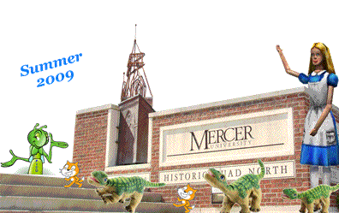

General Camp Information

- Camps run from 8:30am until 3:30pm each day, M-F.
- Camps will be instructed by a college faculty member, a Middle or High School teacher and a student assistant.
- Camps meet in the Computer Science Building on Mercer’s Macon Campus (directions will be sent to campers).
- Each Camp costs $180/camper.
- A limited number of need-based scholarships will be made available for each camp.
- Lunch is included in the price and will be served in Mercer’s Fresh Food Company (dining hall).
- Campers will receive a Camp T-shirt.
- Recreational breaks will be given each day.
- A maximum of 20 campers can attend each camp.
- For more information please call Mrs. Devero at
478-301-2823.

Camp Application

Students who are interested in attending a camp should send the following information to camps@cs.mercer.edu
- Your full name, and which camp you want to attend.
- Name of your current school.
- Your age and current grade in school.
- Your home address and phone number.
- Parent or guardian’s name and contact information.
- Do you want to apply for a need-based scholarship?
Space is limited. Any positive statements also emailed to us from your teachers will be considered as we review applications.
Middle School Camps

PicoCrickets and Scratch Camp – July 13 – 17, 2009
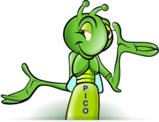
Campers will first learn to create their own animated movie, digital story or computer game in Scratch (http://scratch.mit.edu/). We will then create amazing programmable toys with the PicoCricket Kits (http://www.picocricket.com).

Alice and Pleo Camp – July 20 - 24, 2009
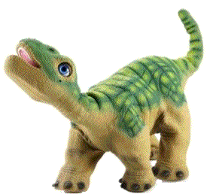
Campers will learn how to design and create interactive virtual worlds with 3-D animations in Alice (http://alice.org). Campers will also learn how to program Pleo the Dinosaur. Pleo consists of many moving parts and sensors that can be programmed to interact with humans (http://www.pleoworld.com/).

High School Camp

Pleo and Alice Camp – July 13 - 17, 2009
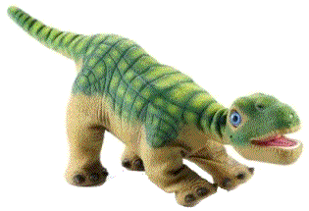
Campers will learn how to design and create interactive virtual worlds with 3-D animations in Alice (http://alice.org). Campers will also learn how to program Pleo the Dinosaur. Pleo consists of many moving parts and sensors that can be programmed to interact intelligently with humans and the surrounding world (http://www.pleoworld.com/).

